**Machine Learning: Assignment 9**

# 

# Submitted to:

Dr. Awais Hassan

# 

# Submitted by:

Komal Shehzadi (2020-MSCS-590)



**Discussion:**

Two code files are submitted for logistic regression one with automatic calculation and confusion matrix and other with manual calculation of weights and costs with prediction and accuracy. Both are almost same because they are showing same results accuracy is quite same in both cases in manual calculation the two data columns are taken in account but for automatic all the columns are taken to calculate the results.

**Specifications:**

alpha = 0.001

iterations = 300

initial_weights = [[0],[0]]

**Output:**

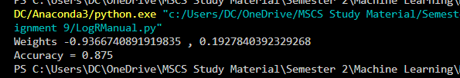

Weight 0:

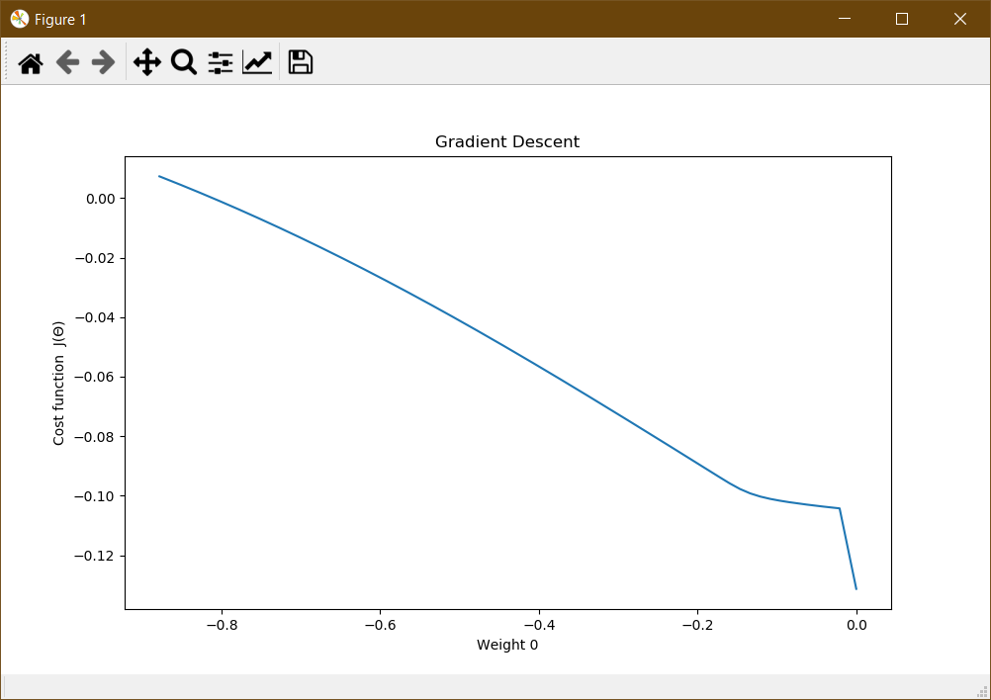

Weight 1:

